What is Transmission media?

* Transmission media is a communication channel that carries the information from the sender to the receiver. Data is transmitted through the electromagnetic signals.
* The main functionality of the transmission media is to carry the information in the form of bits through **LAN**(Local Area Network).
* It is a physical path between transmitter and receiver in data communication.
* In a copper-based network, the bits in the form of electrical signals.
* In a fibre based network, the bits in the form of light pulses.
* In **OSI**(Open System Interconnection) phase, transmission media supports the Layer 1. Therefore, it is considered to be as a Layer 1 component.
* The electrical signals can be sent through the copper wire, fibre optics, atmosphere, water, and vacuum.
* The characteristics and quality of data transmission are determined by the characteristics of medium and signal.
* Transmission media is of two types are wired media and wireless media. In wired media, medium characteristics are more important whereas, in wireless media, signal characteristics are more important.
* Different transmission media have different properties such as bandwidth, delay, cost and ease of installation and maintenance.
* The transmission media is available in the lowest layer of the OSI reference model, i.e., **Physical layer**.

Some factors need to be considered for designing the transmission media:

* **Bandwidth:** All the factors are remaining constant, the greater the bandwidth of a medium, the higher the data transmission rate of a signal.
* **Transmission impairment:** When the received signal is not identical to the transmitted one due to the transmission impairment. The quality of the signals will get destroyed due to transmission impairment.
* **Interference:** An interference is defined as the process of disrupting a signal when it travels over a communication medium on the addition of some unwanted signal.

Causes Of Transmission Impairment:

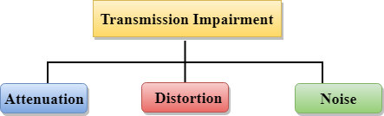

* **Attenuation:** Attenuation means the loss of energy, i.e., the strength of the signal decreases with increasing the distance which causes the loss of energy.
* **Distortion:** Distortion occurs when there is a change in the shape of the signal. This type of distortion is examined from different signals having different frequencies. Each frequency component has its own propagation speed, so they reach at a different time which leads to the delay distortion.
* **Noise:** When data is travelled over a transmission medium, some unwanted signal is added to it which creates the noise.

Classification Of Transmission Media:

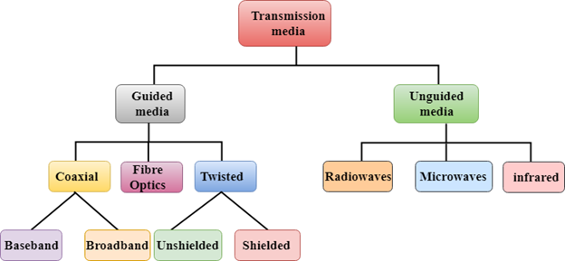

* [Guided Transmission Media](https://www.javatpoint.com/guided-transmission-media)
* [UnGuided Transmission Media](https://www.javatpoint.com/unguided-transmission-media)

Guided Media

It is defined as the physical medium through which the signals are transmitted. It is also known as Bounded media.

Types Of Guided media:

Twisted pair:

Twisted pair is a physical media made up of a pair of cables twisted with each other. A twisted pair cable is cheap as compared to other transmission media. Installation of the twisted pair cable is easy, and it is a lightweight cable. The frequency range for twisted pair cable is from 0 to 3.5KHz.

A twisted pair consists of two insulated copper wires arranged in a regular spiral pattern.

The degree of reduction in noise interference is determined by the number of turns per foot. Increasing the number of turns per foot decreases noise interference.

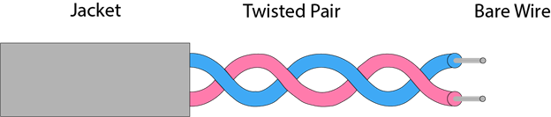

**Types of Twisted pair:**

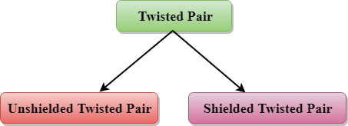

Unshielded Twisted Pair:

An unshielded twisted pair is widely used in telecommunication. Following are the categories of the unshielded twisted pair cable:

* **Category 1:** Category 1 is used for telephone lines that have low-speed data.
* **Category 2:** It can support upto 4Mbps.
* **Category 3:** It can support upto 16Mbps.
* **Category 4:** It can support upto 20Mbps. Therefore, it can be used for long-distance communication.
* **Category 5:** It can support upto 200Mbps.

**Advantages Of Unshielded Twisted Pair:**

* It is cheap.
* Installation of the unshielded twisted pair is easy.
* It can be used for high-speed LAN.

**Disadvantage:**

* This cable can only be used for shorter distances because of attenuation.

Shielded Twisted Pair

A shielded twisted pair is a cable that contains the mesh surrounding the wire that allows the higher transmission rate.

**Characteristics Of Shielded Twisted Pair:**

* The cost of the shielded twisted pair cable is not very high and not very low.
* An installation of STP is easy.
* It has higher capacity as compared to unshielded twisted pair cable.
* It has a higher attenuation.
* It is shielded that provides the higher data transmission rate.

**Disadvantages**

* It is more expensive as compared to UTP and coaxial cable.
* It has a higher attenuation rate.
* 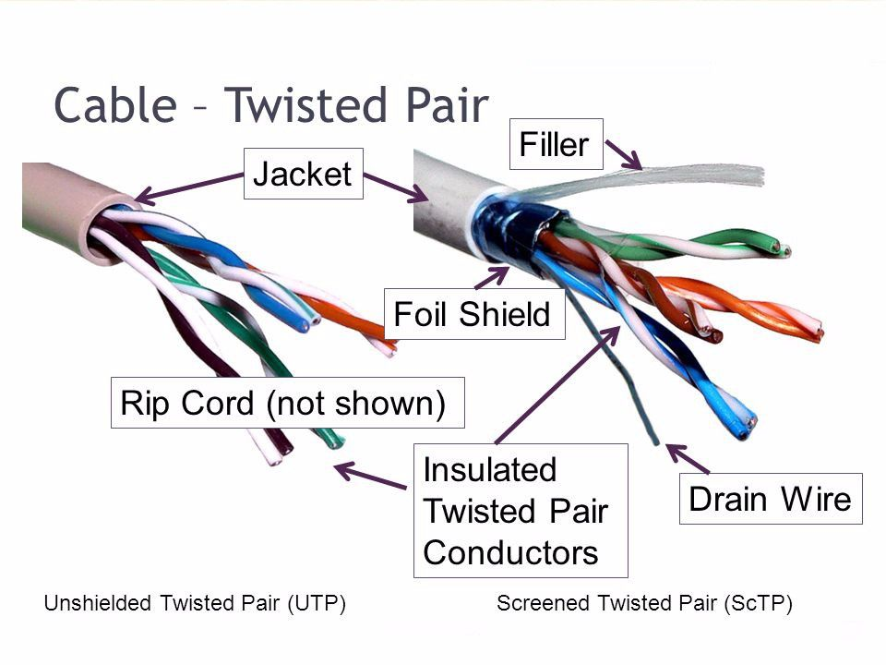

Coaxial Cable

* Coaxial cable is very commonly used transmission media, for example, TV wire is usually a coaxial cable.
* The name of the cable is coaxial as it contains two conductors parallel to each other.
* It has a higher frequency as compared to Twisted pair cable.
* The inner conductor of the coaxial cable is made up of copper, and the outer conductor is made up of copper mesh. The middle core is made up of non-conductive cover that separates the inner conductor from the outer conductor.
* The middle core is responsible for the data transferring whereas the copper mesh prevents from the **EMI**(Electromagnetic interference).

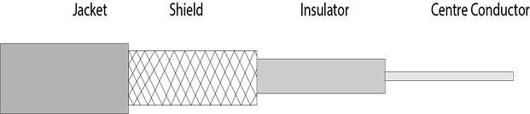

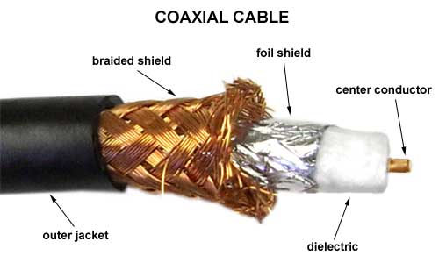

**Coaxial cable is of two types:**

1. **Baseband transmission:** It is defined as the process of transmitting a single signal at high speed.
2. **Broadband transmission:** It is defined as the process of transmitting multiple signals simultaneously.

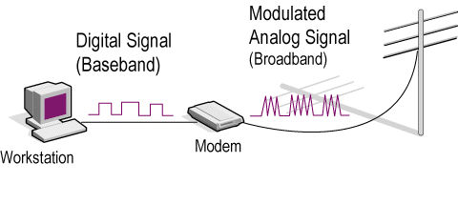

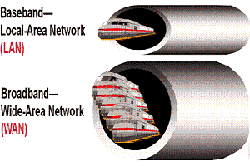

**Advantages Of Coaxial cable:**

* The data can be transmitted at high speed.
* It has better shielding as compared to twisted pair cable.
* It provides higher bandwidth.

**Disadvantages Of Coaxial cable:**

* It is more expensive as compared to twisted pair cable.
* If any fault occurs in the cable causes the failure in the entire network.

Fibre Optic

* Fibre optic cable is a cable that uses electrical signals for communication.
* Fibre optic is a cable that holds the optical fibres coated in plastic that are used to send the data by pulses of light.
* The plastic coating protects the optical fibres from heat, cold, electromagnetic interference from other types of wiring.
* Fibre optics provide faster data transmission than copper wires.

**Diagrammatic representation of fibre optic cable:**

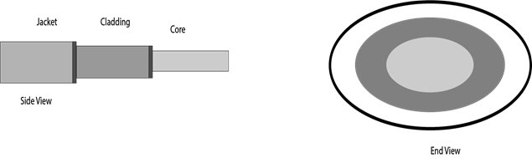

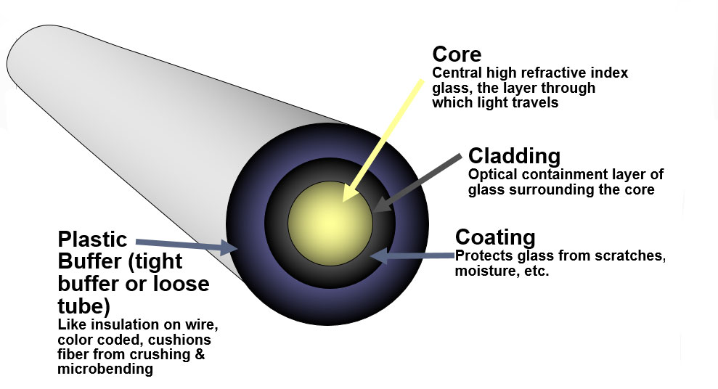

**Basic elements of Fibre optic cable:**

* **Core:** The optical fibre consists of a narrow strand of glass or plastic known as a core. A core is a light transmission area of the fibre. The more the area of the core, the more light will be transmitted into the fibre.
* **Cladding:** The concentric layer of glass is known as cladding. The main functionality of the cladding is to provide the lower refractive index at the core interface as to cause the reflection within the core so that the light waves are transmitted through the fibre.
* **Jacket:** The protective coating consisting of plastic is known as a jacket. The main purpose of a jacket is to preserve the fibre strength, absorb shock and extra fibre protection.
* 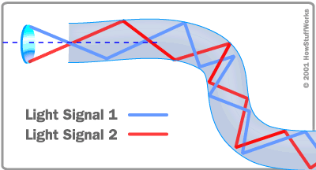

**Following are the advantages of fibre optic cable over copper:**

* **Greater Bandwidth:** The fibre optic cable provides more bandwidth as compared copper. Therefore, the fibre optic carries more data as compared to copper cable.
* **Faster speed:** Fibre optic cable carries the data in the form of light. This allows the fibre optic cable to carry the signals at a higher speed.
* **Longer distances:** The fibre optic cable carries the data at a longer distance as compared to copper cable.
* **Better reliability:** The fibre optic cable is more reliable than the copper cable as it is immune to any temperature changes while it can cause obstruct in the connectivity of copper cable.
* **Thinner and Sturdier:** Fibre optic cable is thinner and lighter in weight so it can withstand more pull pressure than copper cable.

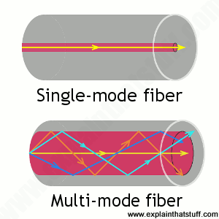

UnGuided Transmission

* An unguided transmission transmits the electromagnetic waves without using any physical medium. Therefore it is also known as **wireless transmission**.
* In unguided media, air is the media through which the electromagnetic energy can flow easily.

Unguided transmission is broadly classified into three categories:

Radio waves

* Radio waves are the electromagnetic waves that are transmitted in all the directions of free space.
* Radio waves are omnidirectional, i.e., the signals are propagated in all the directions.
* The range in frequencies of radio waves is from 3Khz to 1 khz.
* In the case of radio waves, the sending and receiving antenna are not aligned, i.e., the wave sent by the sending antenna can be received by any receiving antenna.
* An example of the radio wave is **FM radio**.

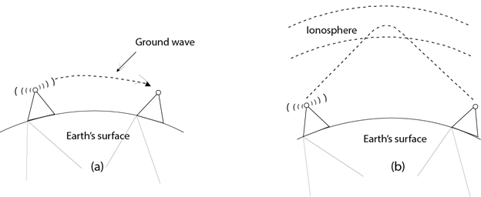

**Applications Of Radio waves:**

* A Radio wave is useful for multicasting when there is one sender and many receivers.
* An FM radio, television, cordless phones are examples of a radio wave.

**Advantages Of Radio transmission:**

* Radio transmission is mainly used for wide area networks and mobile cellular phones.
* Radio waves cover a large area, and they can penetrate the walls.
* Radio transmission provides a higher transmission rate.

Microwaves

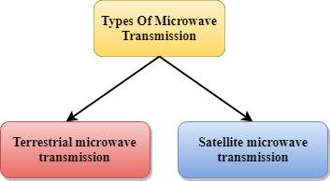

Microwaves are of two types:

* Terrestrial microwave
* Satellite microwave communication.

Terrestrial Microwave Transmission

* Terrestrial Microwave transmission is a technology that transmits the focused beam of a radio signal from one ground-based microwave transmission antenna to another.
* Microwaves are the electromagnetic waves having the frequency in the range from 1GHz to 1000 GHz.
* Microwaves are unidirectional as the sending and receiving antenna is to be aligned, i.e., the waves sent by the sending antenna are narrowly focussed.
* In this case, antennas are mounted on the towers to send a beam to another antenna which is km away.
* It works on the line of sight transmission, i.e., the antennas mounted on the towers are the direct sight of each other.

**Characteristics of Microwave:**

* **Frequency range:** The frequency range of terrestrial microwave is from 4-6 GHz to 21-23 GHz.
* **Bandwidth:** It supports the bandwidth from 1 to 10 Mbps.
* **Short distance:** It is inexpensive for short distance.
* **Long distance:** It is expensive as it requires a higher tower for a longer distance.
* **Attenuation:** Attenuation means loss of signal. It is affected by environmental conditions and antenna size.

**Advantages Of Microwave:**

* Microwave transmission is cheaper than using cables.
* It is free from land acquisition as it does not require any land for the installation of cables.
* Microwave transmission provides an easy communication in terrains as the installation of cable in terrain is quite a difficult task.
* Communication over oceans can be achieved by using microwave transmission.

**Disadvantages of Microwave transmission:**

* **Eavesdropping:** An eavesdropping creates insecure communication. Any malicious user can catch the signal in the air by using its own antenna.
* **Out of phase signal:** A signal can be moved out of phase by using microwave transmission.
* **Susceptible to weather condition:** A microwave transmission is susceptible to weather condition. This means that any environmental change such as rain, wind can distort the signal.
* **Bandwidth limited:** Allocation of bandwidth is limited in the case of microwave transmission.

Satellite Microwave Communication

* A satellite is a physical object that revolves around the earth at a known height.
* Satellite communication is more reliable nowadays as it offers more flexibility than cable and fibre optic systems.
* We can communicate with any point on the globe by using satellite communication.

**How Does Satellite work?**

The satellite accepts the signal that is transmitted from the earth station, and it amplifies the signal. The amplified signal is retransmitted to another earth station.

**Advantages Of Satellite Microwave Communication:**

* The coverage area of a satellite microwave is more than the terrestrial microwave.
* The transmission cost of the satellite is independent of the distance from the centre of the coverage area.
* Satellite communication is used in mobile and wireless communication applications.
* It is easy to install.
* It is used in a wide variety of applications such as weather forecasting, radio/TV signal broadcasting, mobile communication, etc.

**Disadvantages Of Satellite Microwave Communication:**

* Satellite designing and development requires more time and higher cost.
* The Satellite needs to be monitored and controlled on regular periods so that it remains in orbit.
* The life of the satellite is about 12-15 years. Due to this reason, another launch of the satellite has to be planned before it becomes non-functional.

Infrared

* An infrared transmission is a wireless technology used for communication over short ranges.
* The frequency of the infrared in the range from 300 GHz to 400 THz.
* It is used for short-range communication such as data transfer between two cell phones, TV remote operation, data transfer between a computer and cell phone resides in the same closed area.

**Characteristics Of Infrared:**

* It supports high bandwidth, and hence the data rate will be very high.
* Infrared waves cannot penetrate the walls. Therefore, the infrared communication in one room cannot be interrupted by the nearby rooms.
* An infrared communication provides better security with minimum interference.
* Infrared communication is unreliable outside the building because the sun rays will interfere with the infrared waves.